Build a VectorBased Document Retrieval System
What are Vector Embeddings?
Vector embedding are digital fingerprints or numerical representations of words or other pieces of data. Each object is transformed into a list of numbers called a vector. These vectors captures properties of the object in a more manageable and understandable form for machine learning models.
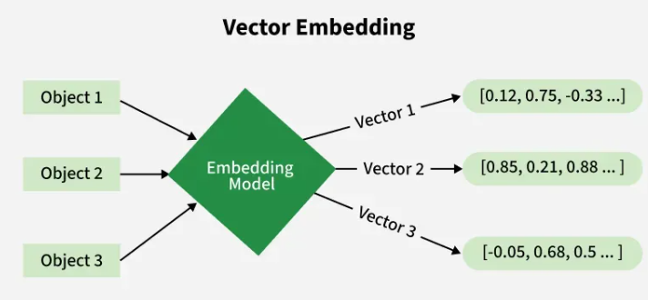
Here, each object is transformed into a numerical vector using an embedding model. These vectors are capturing features and relationships.

What are Vectors?
- A vector is a one dimensional array of numbers containing multiple scalars of the same type of data.
- Vectors represent properties, features in a more machine understandable way.
- Let's take an example to represent vectors: representation of vectors
import numpy as np
vector_sales= np.array([0.4, 0.3, 0.8])
vector_cost= np.array([0.2, 0.3, 0.1])
vector_prices= np.array([0.9, 0.8, 0.7])

Why do we use Vector embedding?
- Compare Similarities: Vector embeddings quantify semantic similarity by measuring the distance between word vectors, if two vectors are in the same direction they are considered similar.
- Clustering: Machine learning algorithms like k means clustering or DBSCAN can be applied directly to vector embeddings to group related data.
- Perform Arithmetic operations: Vector embeddings can perform mathematical operations. These operations allow embeddings to encode rich structured relationships between entities and are used in knowledge representation, analogy solving tasks and AI reasoning.
- Feed machine understandable data: Vector embeddings convert complex and unstructured data into one dimensional arrays called vectors. These vectors can then be used for various applications.

Types of Vector embeddings

1. Word embedding
- Word embeddings captures not only the semantic meaning of words but also their contextual relationship to other words which help them to classify similarities and cluster different points based on their properties and features.
- For example:
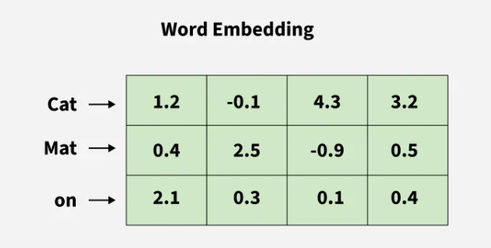
In this image, each word is transformed into numeric vectors and similar words have closer vector representations allowing models to understand the relationship between them.

2. Sentence embedding
- Sentence embeddings aims at finding the semantic meaning of entire phrases or sentences rather than individual words. They are generated with SBERT or other variants of sentence transformers.
- For example:
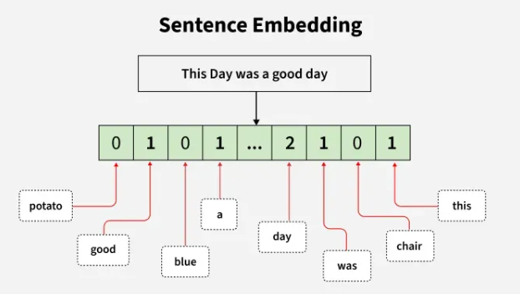
In this image, each word of the sentence is transformed into numeric vectors and zero is imparted to words which are not present in the sentence.

3. Image embedding
- Image embeddings transform images into numerical representations through which our model can perform image search, object recognition, and image generation.
- For example:
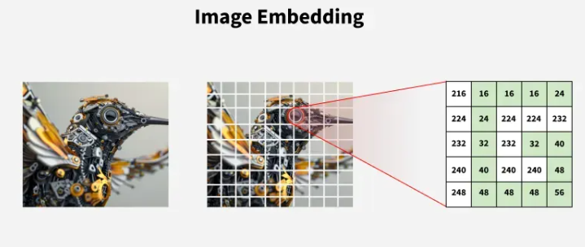
In this image, image is converted into numerical vectors. Image is divided into grids then we have represented each part using pixel values.

4. Multimodal embedding
- Multimodal embedding combines different types of data models into a shared embedding space.
- For example:
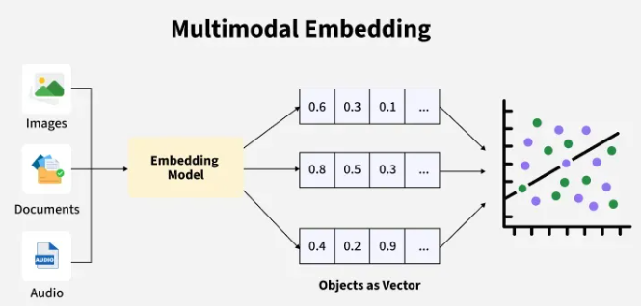
In this image, data from different sources is processed by a shared embedded model which converts all modalities into numerical vectors.

How do Vector embedding work?
Let us take an example of Word embedding to understand how vectors are generated by taking emotions. Here we are transforming each emoji into a vector and the conditions will be our features.
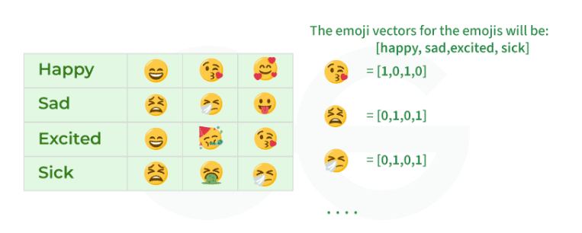

Applications
- Image embeddings transform images into numerical representations to perform image search, object recognition, and image generation.
- Product embeddings give personalized recommendations in the field of e-commerce by finding similar products based on user preferences and purchase history.
- Audio embeddings can be used to transform audio data into embeddings to revolutionize music discovery and speech recognition.
- Time series data can be converted into embeddings to uncover hidden patterns and make accurate predictions.
- Graph data like social networks can be represented as vectors to analyze complex relationships and extract valuable features.
- Document embeddings can be used to transform documents into embeddings that can be used in power efficient search engines.
When working with machine learning models, artificial intelligence and natural language a vector database plays an important role in storing and querying vectorised data. This data can represent anything from text and images to more complex data structures.
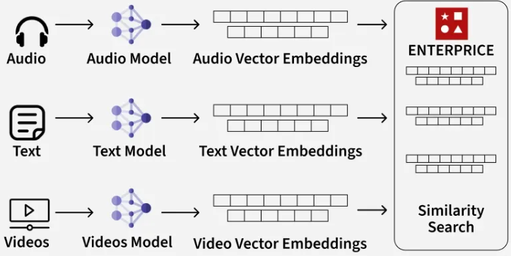

What is vector Database?
A vector database is a type of database that stores vectors. Vectors are numerical representations of data, often generated by machine learning models. These databases are used to manage and retrieve high-dimensional data such as word embeddings (for text), feature vectors (for images) or other data types that require fast retrieval and similarity search. In simpler terms, vector databases help us quickly find similar data points in a large set by comparing their vector representations.

Key features to look for in a Vector Database
When choosing a vector database, certain features are important to check,
- Scalability: The database should handle growing data efficiently without performance slowdowns, especially with large datasets of millions or billions of vectors.
- Search Speed: It uses indexing techniques like HNSW or IVF for quick similarity searches, especially for real-time applications.
- Accuracy: The database should balance accuracy and speed. For critical applications like healthcare or legal fields, prioritize accuracy in search results.
- Support for High-Dimensional Data: The database must handle and search high-dimensional vectors effectively.
- Integration Capabilities: Ensure the database integrates with our existing systems and tools such as Python SDKs or APIs.
- Ease of Use: Choose a database that matches our team's technical skill level, it could offers user-friendly interfaces or command-line tools.
- Cost: Consider both upfront and long-term costs. Some databases are free (open-source) while others may require a paid license.
- Data Security: The database should offer encryption, authentication and other features to protect sensitive data.

Popular Vector Databases
Lets see various vector databases and their working and use case:

1. Pinecone
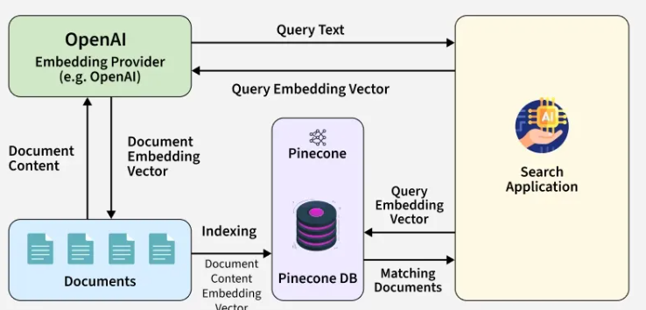
Pinecone is a managed vector database ideal for machine learning applications. It offers scalability, fast search speeds and integrates well with ML frameworks, supporting both real-time and batch indexing for tasks like recommendation systems and semantic search.
- Advantage: Fully managed, easy to integrate with ML frameworks and automatically scales.
- Limitation: Subscription-based pricing may not be cost-effective for small projects.

2. Faiss (Facebook AI Similarity Search)
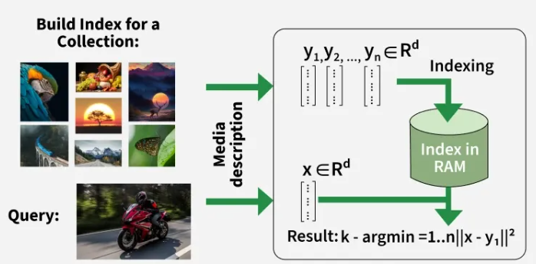
Faiss is an open-source vector search library by Facebook AI and is known for its high performance with large datasets. It supports various indexes and handles high-dimensional data well. It’s a great, customizable choice but requires more technical setup.
- Advantage: High performance and customizable, ideal for large-scale datasets.
- Limitation: Requires technical expertise and significant setup effort.

3. Weaviate
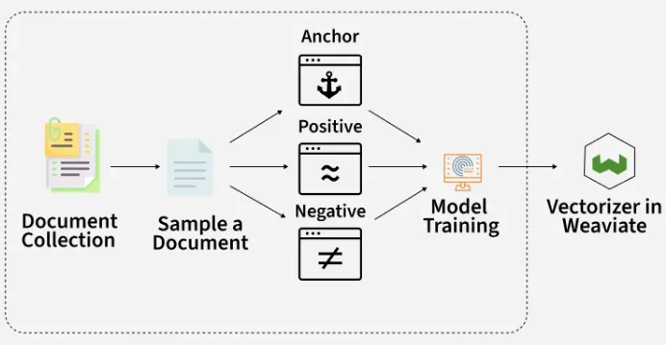
Weaviate is an easy-to-use open-source vector database with built-in machine learning models for automatic vectorization. It supports different vector search types and is ideal for straightforward setups and seamless integration with other systems.
- Advantage: User-friendly with built-in machine learning models for automatic vectorization.
- Limitation: May not scale as efficiently for very large datasets.

4. Qdrant
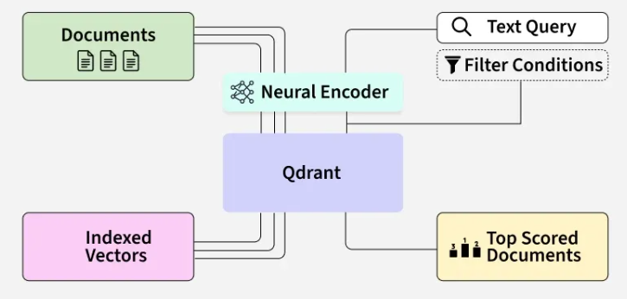
Qdrant is an open-source vector database designed for high-dimensional vectors. It supports traditional and real-time search and is ideal for applications like recommendation systems, semantic search and image recognition.
- Advantage: Optimized for real-time search with high-dimensional data support.
- Limitation: Newer technology with potentially fewer features compared to more mature solutions.

5. ChromaDB
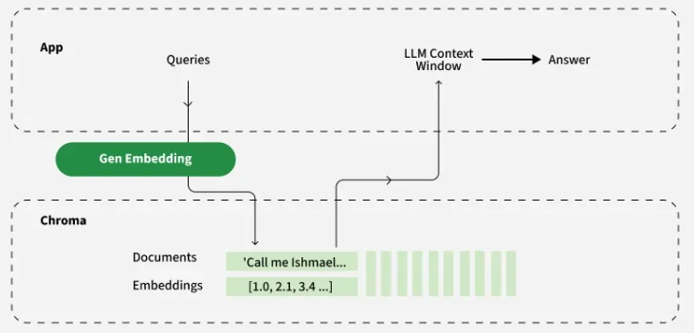
ChromaDB is an open-source vector database focused on embedding management and retrieval. It’s built specifically for AI and LLM use cases like semantic search, document retrieval and agent memory. It integrates tightly with Python and supports storing both vectors and associated metadata in a simple, developer-friendly API.
- Advantage: Designed for LLM and AI workflows with built-in support for metadata, filtering and seamless integration into Python pipelines.
- Limitation: Primarily optimized for local and prototyping environments, lacks the scalability and distributed architecture of more production-focused databases.

Comparison Table
Feature | Pinecone | FAISS | ChromaDB | Weaviate | Qdrant
Scalability | High (Managed Service) | High (Requires Setup) | Moderate (best for local and prototype use) | High (Scalable for various use cases) | High (Designed for high scale)
Speed | Fast (real-time and batch) | Fast (Optimized for large datasets) | Fast (lightweight for local/vector queries) | Fast (Supports semantic search) | Fast (real-time search)
Accuracy | High (optimized for similarity) | High (with tuning) | High (optimized for embedding-centric search) | High (semantic search optimized) | High (balanced accuracy)
Data Security | High (managed service with security features) | Moderate (depends on implementation) | Moderate (local storage, depends on hosting setup) | High (supports encryption) | High (supports encryption)
Integration | Easy (supports popular ML frameworks) | Requires custom integration | Easy (Python-first, LangChain, LlamaIndex support) | Easy (supports various systems) | Easy (supports APIs/SDKs)
Ideal Use case | Real-time ML applications, semantic search | Large datasets, customizable search | Prototyping, AI agent memory, semantic document retrieval | Semantic search, automatic vectorization | Real-time applications, semantic search

Choosing the Right Vector Database for Our Use Case
- If we need speed and scalability: Pinecone and ChromaDB are great options for real-time performance at scale.
- If we want something open-source and customizable: Faiss and Qdrant are good choices.
- If our project involves large-scale text or semantic search: Pinecone and Weaviate are best for it.
- If we want simplicity: Weaviate is a user-friendly option with automatic machine learning model integration.

Considerations for Data Storage and Indexing
- Indexing Type: The type of indexing used like IVF, HNSW, etc will impact search speed and accuracy. Some databases provide options for multiple indexing techniques giving us the flexibility to choose based on our specific needs.
- Data Updates: Consider how often our data will be updated. Some vector databases are optimized for fast batch updates while others may be better suited for applications where data doesn't change frequently.
Implementing Semantic Search with Vector database
Semantic Search is an advanced search technique that enhances traditional search techniques by focusing on understanding the meaning or intent behind a query, rather than relying solely on exact keyword matches. This approach enables the system to interpret the context, relationships and underlying semantics of the words in both the query and the documents, resulting in more relevant and precise search outcomes that align with the user's true intent.

Key Concepts
Vector embeddings are dense representations of text in a high-dimensional space. Each word or document is transformed into a vector, where similar meanings are close to each other in the vector space. By using vector databases and embeddings we can capture the relationships between words and concepts.
How Vector Embeddings Work:
- Word Embeddings: Words are represented as vectors in high-dimensional space, where semantically similar words, like "dog" and "puppy" are close together.
- Sentence/Document Embeddings: Whole sentences or documents are also represented as vectors, capturing the overall meaning. Models like BERT, Word2Vec and Sentence-BERT generate these embeddings by mapping text into vectors while preserving contextual relationships.
- Dimensionality: Embeddings are high-dimensional with each dimension encoding abstract features of the text. More dimensions allow for richer information.
- Cosine Similarity: To measure similarity between vectors, cosine similarity is used to calculate the cosine of the angle between them where smaller angles indicate higher similarity.
Vector Database: A vector database is designed to store and query vector embeddings. Unlike traditional relational databases which are optimized for structured data, vector databases are optimized for similarity searches. These databases provide efficient methods to store and retrieve vectors by their similarity making them ideal for semantic search applications.
How Vector Databases Work:
- Storage: Vector databases store large volumes of embeddings, representing text (words, sentences, documents) as coordinates in high-dimensional space.
- Indexing: Specialized indexing techniques enable fast retrieval of similar vectors by organizing them for efficient similarity searches.
- Similarity Search: Queries are transformed into vector embeddings and the database retrieves the most similar vectors using distance metrics like cosine or Euclidean distance.
- Approximate Nearest Neighbor (ANN): Approximate Nearest Neighbor algorithms like HNSW or LSH optimize searches by providing fast, approximate results, balancing speed and accuracy.
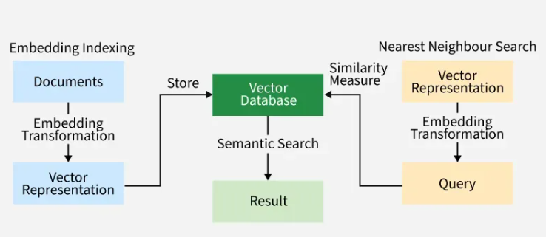

Steps to Implement Semantic Search with a Vector Database
Lets understand the implementation of semantic search with vector database with following steps:

Step 1: Import Libraries
- sentence_transformers: For generating sentence embeddings (vector representations).
- faiss: For performing similarity search on vector embeddings we will use faiss.
- NumPy: NumPy is used for handling numerical arrays and converting embeddings.
from sentence_transformers import SentenceTransformer
import faiss
import numpy as np

Step 2: Generate Vector Embeddings
- Load a pre-trained model all-MiniLM-L6-v2.
- Convert the list of documents into vector embeddings using the model.
model = SentenceTransformer('all-MiniLM-L6-v2')
documents = [
"The quick brown fox jumps over the lazy dog",
"A journey of a thousand miles begins with a single step",
"To be or not to be, that is the question",
"A ride full of surprises and joy starts tomorrow"
]
embeddings = model.encode(documents)

Step 3: Create the FAISS Index
- Convert embeddings to float32 format for FAISS compatibility.
- Create a FAISS index with the L2 distance metric and add the embeddings to the index.
embeddings_np = np.array(embeddings).astype('float32')
index = faiss.IndexFlatL2(embeddings_np.shape[1])
index.add(embeddings_np)

Step 4: Querying the Database
- Generate an embedding for the query.
- Perform a similarity search in the FAISS index, retrieve the most similar document and display the result.
- D: A NumPy array containing the distances between the query's embedding and the document embeddings in the FAISS index. Smaller distances indicate more similarity.
- I: A NumPy array containing the indices of the most similar documents from the documents list, based on the similarity scores.
- k=1: This means that the code will return the single most similar document to the query i.e only the top 1 result based on similarity.
query = "What is the first step of a long journey?"
query_embedding = model.encode([query])
D, I = index.search(np.array(query_embedding).astype('float32'), k=1)
print(f"Most similar document: {documents[I[0][0]]}")


Step 5: Improve Search Results
- Fine-tune the sentence transformer model for your specific domain or dataset.
- Use hierarchical indexing or more complex indexing structures available in FAISS or other vector databases.
- Experiment with different distance metrics like cosine similarity, which often works better in high-dimensional spaces.

Use Cases of Semantic Search
- E-commerce: Enhance product search by interpreting user intent even when different terms or phrases are used to describe the same product.
- Document Retrieval: Retrieve the most relevant documents or articles based on their semantic meaning not just exact keyword matches.
- Customer Support: Improve search results for FAQs and support tickets by understanding the context of user queries, leading to more accurate responses.
- Healthcare: Streamline the retrieval of medical research, patient records or clinical notes by understanding the relationships and context within the data.

Advantages of Using a Vector Database for Semantic Search:
- Contextual Relevance: Finds documents based on meaning not just keywords.
- Handling Synonyms: Can retrieve relevant documents even if different terms or synonyms are used in the query and documents.
- Scalability: Vector databases are designed to handle large datasets making them ideal for applications like e-commerce, document retrieval and knowledge graphs.
- Speed: With indexing and ANN vector databases provide fast, real-time similarity searches even for massive collections.
Vector databases enhance LLMs by providing contextual, domain-specific knowledge beyond their training data. This integration solves key LLM limitations like illusions and outdated information by enabling:
- Retrieval-Augmented Generation (RAG): Retrieve relevant context before response generation.
- Semantic search: Find contextually similar data even without exact keywords.
- Dynamic knowledge enrichment: Inject real-time data into LLMs without retraining.
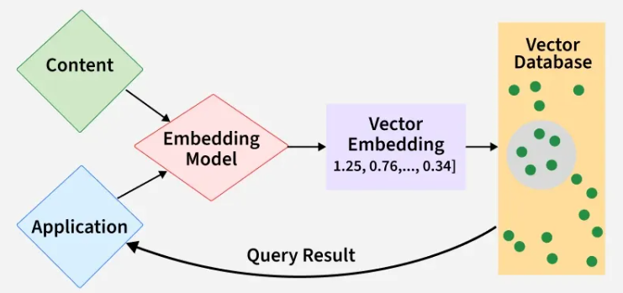

Real-World Example: Research Assistant
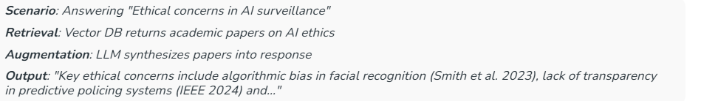

End-to-End Implementation Workflow

Step 1: Install Required Libraries
!pip install google-generativeai chromadb
- google-generativeai: Access Gemini API for embeddings and LLM.
- chromadb: Open-source vector database for storing and searching embeddings.

Step 2: Embedding Generation with Gemini API
import google.generativeai as genai

# Authenticate with your Gemini API key
genai.configure(api_key="YOUR_GEMINI_API_KEY")

# Generate an embedding for a text string
def get_embedding(text):
client = genai.Client()
result = client.models.embed_content(
model="text-embedding-004", # Use the latest available embedding model
contents=text
)
return result.embeddings
- Replace "YOUR_GEMINI_API_KEY" with your actual API key.
- The function returns a vector representation of the input text.

Step 3: Vector Database Setup
- Database Selection Criteria:
Database | Type | Best For
ChromaDB | Open-source | Rapid prototyping
Pinecone | Proprietary | High-scale production
Qdrant | Open-source | Balanced performance
- Store Embeddings in ChromaDB: Each document is embedded and stored with its vector in the database
import chromadb

# Initialize ChromaDB client and collection
client = chromadb.Client()
collection = client.create_collection("my_docs")

# Example data
documents = [
{"id": "1", "text": "Zomato is a food delivery company."},
{"id": "2", "text": "AWS Lambda is used for serverless computing."},
{"id": "3", "text": "GARCH models are used in financial time series analysis."}
]

# Add documents with embeddings
for doc in documents:
embedding = get_embedding(doc["text"])
collection.add(
ids=[doc["id"]],
embeddings=[embedding],
documents=[doc["text"]]
)

Step 4: Query Processing
- The user’s question is embedded and used to search for the most relevant documents in the vector database.
query = "What is GARCH used for?"
query_embedding = get_embedding(query)

# Retrieve top 2 most similar documents
results = collection.query(
query_embeddings=[query_embedding],
n_results=2
)

for doc, score in zip(results['documents'][0], results['distances'][0]):
print(f"Document: {doc}\nSimilarity Score: {score}\n")
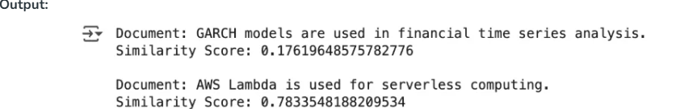

Step 5: Use Retrieved Context with Gemini LLM
The retrieved context is passed to Gemini Flash 2.5 for answer generation, enabling RAG workflows.
# Concatenate retrieved docs as context
context = "\n".join(results['documents'][0])

# Generate answer using Gemini LLM
llm = genai.GenerativeModel("gemini-1.5-flash-latest")
response = llm.generate_content(
f"Based on the following context, answer the question: '{query}'\nContext:\n{context}"
)
print(response.text)
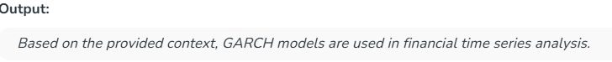

Integration Methods Compared
Method | How It Works | Use Cases
Retrieval (RAG) | External context retrieval pre-generation | Chatbots, Q&A systems
Injection | Embeddings baked into LLM parameters | Domain-specific

Best Practices
1. Chunk Optimization: Test chunk sizes (256-1024 tokens) using ragas framework for evaluation.
2. Embedding Fine-tuning: Adapt embedding models to domain language (e.g., medical/legal jargon)
3. Hybrid Search: Combine vector + keyword search for precision:
results = vector_db.similarity_search(query, filter={"keywords": ["AI ethics"]})
4. Data Validation: Implement automated checks for embedding drift and data staleness

Tools & Frameworks
- Embedding Libraries: sentence-transformers,Gemini Embeddings, OpenAI Embeddings
- Vector DBs: Chroma (local), Pinecone (cloud), Qdrant (self-hosted)
- Evaluation: ragas (RAG metrics), LlamaIndex (retrieval accuracy)

What You're Aiming For
Demonstrate the ability to embed a set of documents into vectors and build a FAISS index for efficient similarity search.

Instructions
- Import FAISS and create an index for similarity search.
import faiss
import numpy as np

# Dimension of embeddings
d = embeddings.shape[1]

# Build index
index = faiss.IndexFlatL2(d) # L2 distance (Euclidean)
index.add(np.array(embeddings)) # Add vectors

- Test Retrieval
  - Embed a query and search the index for the top results.
query = "How can I use AI in industry?"
query_vector = model.encode([query], convert_to_numpy=True)

# Search top 2 results
D, I = index.search(query_vector, k=2)
print("Top Results:")
for idx in I[0]:
print(corpus[idx])

Expected Outcome
- You should be able to query the FAISS index with natural language and retrieve semantically relevant documents.
- Example: Query "AI in i
- Prepare the Document Corpus
  - Collect a small set of documents (e.g., 10–20 text files or a few paragraphs).
  - Example: short articles, product descriptions, or news snippets.
- Generate Embeddings
  - Use a pre-trained sentence embedding model (e.g., sentence-transformers from HuggingFace).
  - Convert each document into a vector representation.
from sentence_transformers import SentenceTransformer

# Load model
model = SentenceTransformer('all-MiniLM-L6-v2')

# Example corpus
corpus = [
"Artificial Intelligence is transforming industries.",
"FAISS enables efficient vector similarity search.",
"Machine learning models require high-quality data.",
"Python is widely used for data science tasks."
]

# Create embeddings
embeddings = model.encode(corpus, convert_to_numpy=True)

- Build a FAISS Index
ndustry" should retrieve "Artificial Intelligence is transforming industries."

Submission Requirement:
Provide your Python notebook or script showing:
- Corpus preparation
- Embedding generation
- FAISS indexing
- Example search results

